MASSGLOBAL CONSULTING

You can download this project from:

<https://github.com/ricardojavister/WEBAPIMASGLOBAL.git>

And don´t forget to start visual studio as administrator and set the project MSGLOBAL.WebApiClient as Startup project

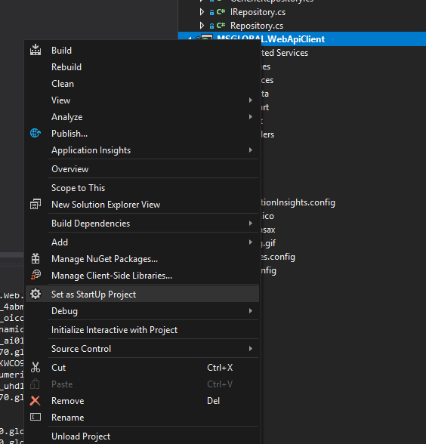

This project contains how to use:

* Repository Pattern
* Factory Pattern

Besides is separated in three layers:

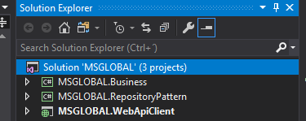

**MSGLOBAL.RepositoryPattern**

A Class library project to make sure that all the responsibilities are segregated.

**MSGLOBAL.Business**

A Class library project to receive requests from Controller that is coming from **MSGLOBAL.WebApiClient,** our MVC Project.

**MSGLOBAL.WebApiClient**

MVC Project responsible for retrieving DATA from a Web Api placed in:

http://masglobaltestapi.azurewebsites.net/api/Employees

## More Detail

**MSGLOBAL.RepositoryPattern**

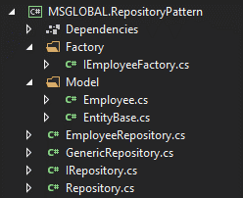

It contains the implementation of repository pattern that is structured by an interface called **IRepository**

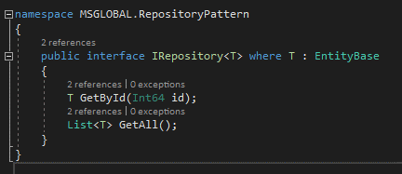

This interface define the common methods that will be implemented by the class **Employee**

**Factory Method**

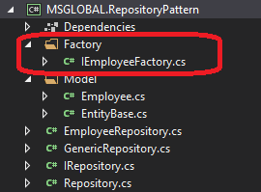

This pattern is useful when you cannot anticipated which class create, so you will need to create an specific class to run different type of process or different implementation of a common method, so in this pattern I take advantage of a **polymorphism behavior**.

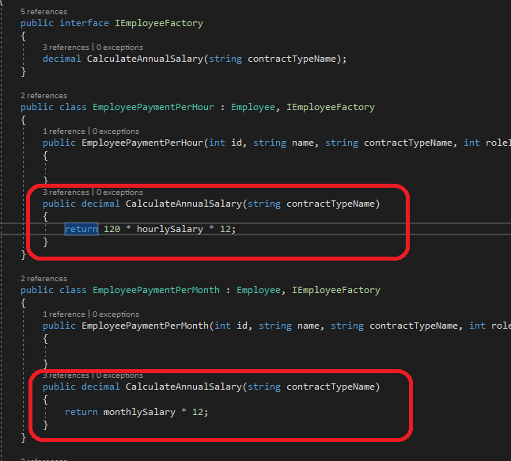

## Results

By using the power of Ajax and Jquery, I implemented a process to filter by the id of the Employee and if the user doesn´t type anything in the textbox, the page will return all the employees.

http://localhost:50487/Employee/Index

Filtering

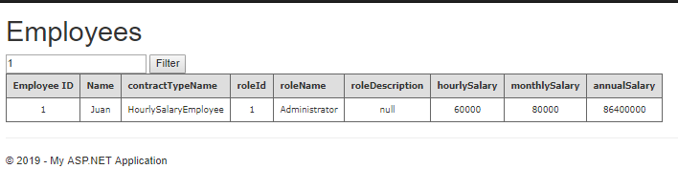

Showing all the Employees

